**BIO-DATA**

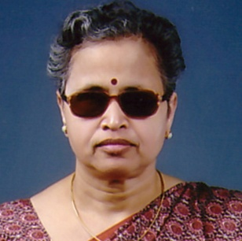

Name : Dr. Smt. Anjali Vasant Nigwekar

Address (Res.) : 11,Akash Ganga Apts.

Rajarampuri 11th Lane, Kolhapur-416008

Phone No. : Res.-0231-2529623, Off.-0231-2609221,

Mob.-9011619200

Title of Ph.D. Thesis: mRrj fganqLFkkuh daBlaxhr&/kzqin&/kekj rs [;ky fufeZrh ,d

vH;kl-

Honours Gained :

* FIRST amongst all Blind Students, SSC Pune Board.
* Recipient of Nagarkar Prize of Pune Board.
* Distinction marks in Music (vocal) at B.A. 7th Place in

Merit List of Nagpur University.

* Recipient of National Merit Scholarship for 2 years

i.e. 1986-87 and 1987-88 for M.A. study.

* First BLIND to secure Ph.D. Degree in Music (vocal) in

Maharashtra State.

* Recipient of World Blind Union Hermione Grant Calhoun Scholarship for the years 1997 and 1998.

AWARD : SCHOLARSHIP :

**NATIONAL AWARD** :

Smt. Neelam Kanga Memorial AWARD (Prestigious National Award) given by National Association for The Blind women who have reached great heights in various fields for the year1994-1995

**INTER NATIONAL SCHOLARSHIP** :

1997-1998 for the study of Ph.D.

* OCCUPATION :

Contributory Teacher in Music (vocal) : Worked as Contributory Music Teacher(vocal) in Music Department, Shivaji University, Kolhapur from 1991-92 to 2003-04 i.e.13years.

* Lecturer in Music (vocal): Working as full-time teacher as Lecturer in Music(vocal),in the University Department of Music Shivaji University, Kolhapur, Since 7th June 2004

**OTHER PARTICIPATIONS**:

Member of the Executive Committee of NAB, Kolhapur Branch. Take active part in all programmes organized by NAB , Kolhapur Branch, Helpers of the Handicapped, Kolhapur.

1. Recipient of Sanskar Bharati, Kolhapur's *Sanman* *Patra* in recognition of contribution to the spread of Music in Kolhapur
2. Recipient of *Nirdhar Puraskar* on the occasionof *Jagtik Apang Chitrapat Mohostav* organized by Kala Maharshi Baburao Painter Film Society, Kolhapur.

**Attended**

* NATIONAL SEMINAR ON MUSICOLOGY: organized by Music Department, University of Mumbai at Mumbai.
* GOAL IN LIFE: To strive for the fulfillment of my mission to create lasting interest amongst students aspiring to learn Musicology both as an ART and SCIENCE.

Paper Published – 2 papers in National Journals.